Fridge Friend Final Report

John Merrill

Sam Chambers

Alex Nevers

**Project goal:**

Our app's purpose is to help users organize and easily visualize their groceries, by using a UPC supplied database. Users will be able to barcode scan their groceries as they unpack them, adding them to their current list with a single button press. Tags such as expiration date and food type are automatically added, so users can easily sort their grocery list by what to eat (or throw away) next.

**Project features:**

* Scan barcodes from camera
* Fetch barcode UPC info using Computer Vision API
* Store UPC Items in a database
* Sort UPC Items by food category or expiration date

**Original Project Design:**

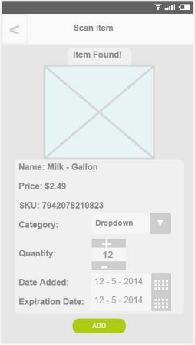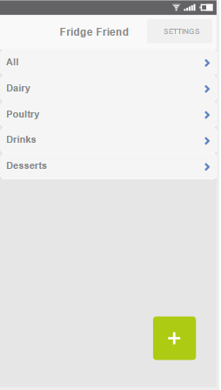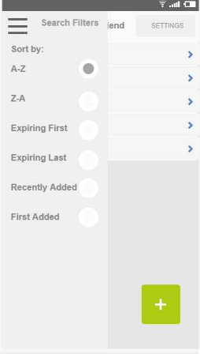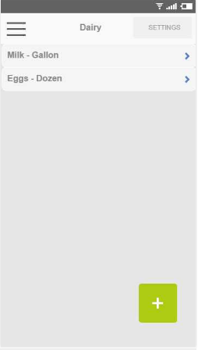

Figure 3: Sorted by Category

Figure 1: Home Page

Figure 2:Results after Barcode Scan

Figure 4:Menu with Sorting Options

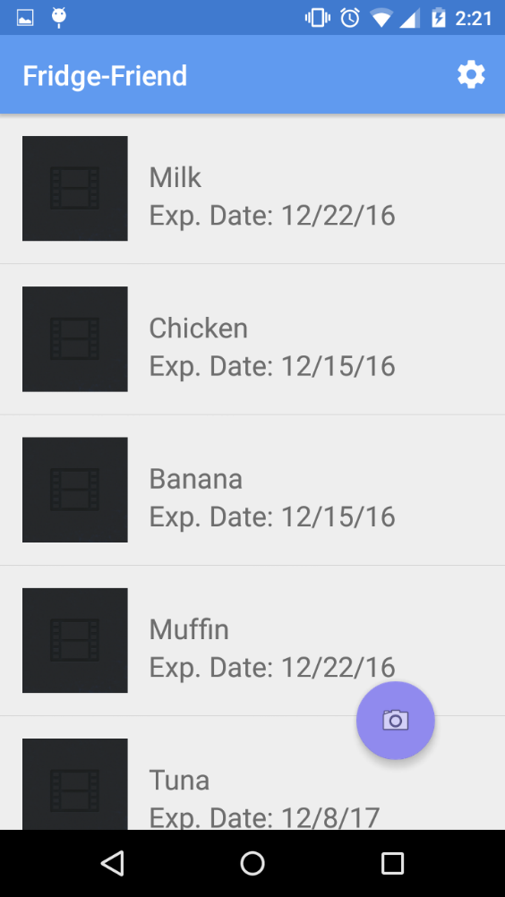**Final Project Design:**

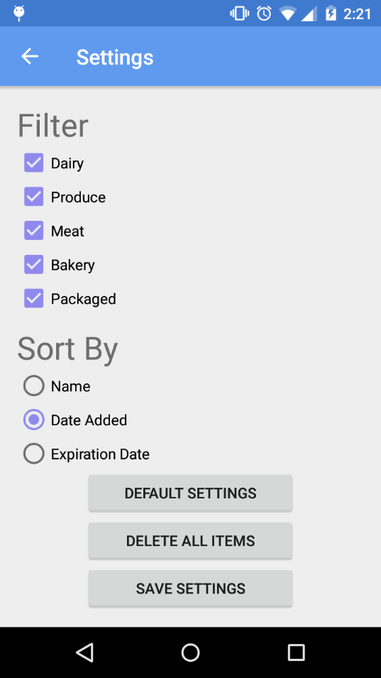

**File Structure:**

UI Files: [Created by Sam, tweaks by Alex]

* Activity_Main: homepage with photo button
* Activity_Results: Results screen after barcode scan; shows product name and info, with Add button
* content_main:
* drawer_list_item:
* list_item: individual xml for each list item

Java Files:

* DBHelper: [Alex] Creates the SQLite Database for storing food items by UPC type including expiry date, type of food, name, etc.
* ItemType: [Sam & John] associates common words in UPC item name with appropriate food category, defines item typing
* MainActivity: [Sam, John, Alex] Displays the homepage with current items in database, along with button to add new via photo
* NetworkUtilis: [John] Handles network operations of looking up barcodes
* Results_Activity: [Sam & Alex] Looks up barcode scan and retrieves UPC Item with description & photo, adds to the database
* UpcItem: [John] Defines a UPC Item including name, item type, and shelf life, to be added to database
* UpcItemLoader: [John] Asynchronously loads UPCItem in background

Other:

* ReadMe: [Alex] Project Report, project links
* Screenshots and Video Demo [Sam]